## Scenario 1: DBS Investment

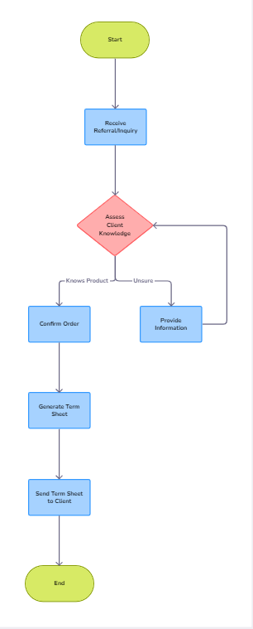

## Scenario 2: Enviro 365 Bank

1. **Let's Identify Who's Involved:** We need to make a list of everyone who could be affected by the new online banking system, like our bank staff, customers, and regulators.
2. **Let's Group the Stakeholders:** We should group them based on how much they're involved and how much they can influence what we're doing.
3. **Figure Out Who Really Matters:** We need to decide which groups are most important and have the most say in what happens.
4. **Let's Understand How They're Connected:** It's important to see how different groups interact and if their interests match or don't match.
5. **Listen to What They Have to Say:** We need to talk to stakeholders to find out what they need from the new system, like better security or easier access.
6. **Look Out for Risks and Opportunities:** We should think about what might go wrong if we don't involve certain groups and how we can benefit by working closely with others.
7. **Make a Plan to Keep Everyone in the Loop:** We need to decide how we'll keep in touch with each group and how often we'll check in with them.
8. **Let's Get Started on Our Plan:** We should start talking to stakeholders regularly and be ready to make changes if things aren't going as planned.
9. **Keep Checking In:** It's important to keep checking if our plan is working and be ready to adjust it if anything changes.

## Scenario 3: Enviro 365 Bank

### User experience requirement list:

1. **Easy-to-Use Website:**
   * Make sure the website is simple to understand and easy for investors to use when they want to withdraw money.
2. **Choosing the Product:**
   * Let investors pick which product they're taking money out of. It should be easy to find and choose.
3. **Entering Withdrawal Amount:**
   * Investors should be able to type in how much money they want to take out. The box where they type should be clear and easy to find, and it should stop them from making mistakes.
4. **Adding Bank Details:**
   * Investors should be able to put in the details of the bank account where they want the money to go. They'll need to give the account number, name, and any other important info.
5. **Getting Notified:**
   * After they've taken out the money, investors should get a message telling them:
     + How much money they had before taking it out.
     + How much they took out.
     + How much they have left after the withdrawal.
6. **Sending Bank Statement:**
   * When investors request a withdrawal, they should also send a copy of their bank statement. We'll need to make it clear how they can do this.
7. **Keeping Things Safe:**
   * We need to make sure the website is really safe so investors' information stays private. This means keeping their details safe when they type them in and when they're stored on the website.
8. **Making it Easy for Everyone:**
   * The website should work for everyone, including people who might have trouble seeing or using a computer. It should be easy to read, use with a keyboard, and adjust the size of the text.
9. **Checking for Mistakes:**
   * If someone makes a mistake when taking out money, we need to let them know and help them fix it. We also need to make sure they've filled in all the necessary info before they finish.
10. **Good on Phones Too:**
    * The website should work just as well on phones and tablets as it does on computers, so investors can take out money from anywhere.
11. **Giving Feedback:**
    * We need to let investors know what's happening at each step of the process, so they're not left wondering if their request went through or not.
12. **Helping Out:**
    * There should be clear instructions and tips on the website to help investors understand how to take out money and what to do if something goes wrong.
13. **Following the Rules:**
    * The website needs to follow all the rules and laws about handling money and keeping people's information safe. This means making sure everything is done the right way according to the law.

### Prototype:

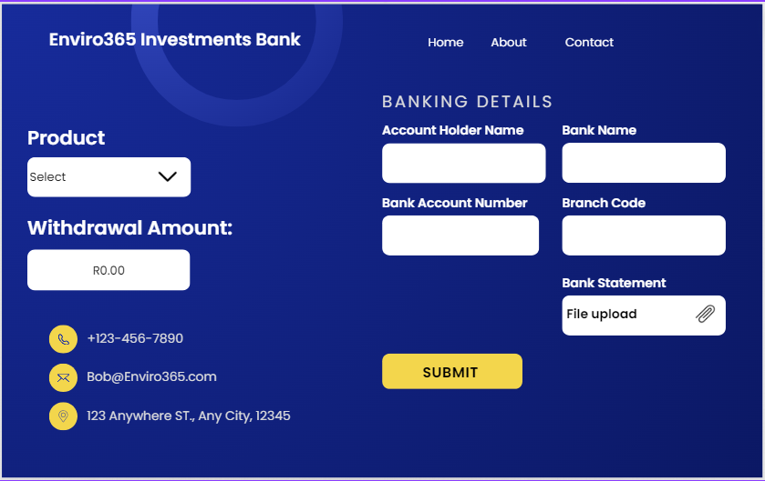

## Scenario 4: Enviro 365 Bank data definitions

|  |  |  |  |
| --- | --- | --- | --- |
| **Entity name:** | **CUSTOMER** |  |  |
| **Attribute** | **Key (PK / FK)** | **Data type** | **Data size** |
| Customer ID | PK | String | 4 bytes |
| Create date (when the ‘Customer’ record was created) |  | Date/Time | 8 bytes |
| Status (e.g. Good, Blacklisted) |  | String | 10 bytes |
| First name |  | String | 20 bytes |
| Last name |  | String | 20 bytes |
| Email |  | String | 50 bytes |
| Cell phone |  | String | 15 bytes |
| Date of birth |  | Date | 8 bytes |
| Address line 1 |  | String | 50 bytes |
| Zip code |  | String or integer | 10 bytes |
| Gender (e.g. Female, Unknown) |  | String | 10 bytes |

|  |  |  |  |
| --- | --- | --- | --- |
| **Entity name:** | **ORDER** |  |  |
| **Attribute** | **Key (PK / FK)** | **Data type** | **Data size** |
| Order ID | PK | String or integer | 4 bytes |
| Create date (when the cart record was created) |  | Date/Time | 8 bytes |
| Status (e.g. Paid, Abandoned, Dispatched) |  | String | 10 bytes |
| Order date (when the cart was checked out and paid) |  | Date/Time | 8 bytes |
| Customer ID | FK | String or Integer | 4 bytes |
| Total pre-tax value |  | Decimal or Float | 8 bytes |
| Total tax value |  | Decimal or Float | 8 bytes |
| Total order value |  | Decimal or Float | 8 bytes |
| Total quantity of products |  | Integer | 4 bytes |